New liver distribution policy – a visual guide
The OPTN/UNOS Board of Directors recently approved a new liver distribution system to replace fixed, irregular local and regional geographic boundaries historically used for liver distribution with more consistent measures. The Scientific Registry of Transplant Recipients (SRTR) performed simulation modeling to assess potential outcomes of this and other policy alternatives. In addition, more than 1,200 public comments guided consideration of the new system.
The new policy replaces all donation service area (DSA) and regional boundaries currently used in liver and intestine distribution with distribution zones (circles) of varying distances from the donor hospital. Similar to previous liver policy, candidates of the highest medical urgency (Status 1A and 1B) will have broader access to organ offers before less urgent candidates who are closer to the donor hospital.
The following information illustrates how the system will prioritize liver transplant candidates.
As in current liver distribution, livers from adult deceased donors first will be offered to a wide area for candidates in the most urgent (Status 1A and 1B) designations, because they are at great risk of imminent death without a transplant. At any given moment, there are generally fewer than 50 Status 1A and 1B candidates listed nationwide.
Under the new policy, livers from all deceased donors would be offered for compatible Status 1A and 1B candidates listed at transplant hospitals within a radius of 500 nautical miles of the donor hospital. In the example below, transplant hospitals A, B and C all have Status 1A or 1B candidates compatible with the donor and are located within a 500 nautical-mile radius of the donor hospital.
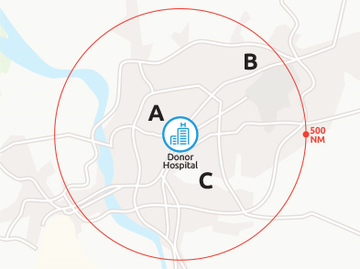

After offers to Status 1A and 1B candidates, livers from deceased adult donors will be distributed in one of two ways depending on the donor’s age and mechanism of death. The examples below illustrate how the system will work based on different characteristics of the deceased donor.

Organ distribution for adult, non-DCD donors younger than age 70
The majority of deceased liver donors are adults who are under age 70 and who are not donating upon cardiorespiratory death (also known as DCD donation). For livers from these donors, after initial offers to Status 1A and 1B candidates as above, the next steps in distribution are as follows:
- candidates with a MELD or PELD score of 37 or higher listed at transplant hospitals within a radius of 150 nautical miles from the donor hospital
- candidates with a MELD or PELD score of 37 or higher listed at transplant hospitals within a radius of 250 nautical miles from the donor hospital
- candidates with a MELD or PELD score of 37 or higher listed at transplant hospitals within a radius of 500 nautical miles from the donor hospital
- a continuing sequence of progressive offers, from more local to more distant (at transplant hospitals within 150, 250 and 500 nautical miles of the donor hospital), for candidates with ranges of MELD or PELD scores from 33 to 36, from 29 to 32, and from 15 to 28
In the example below:
- Transplant hospital A is within the 150 nautical-mile radius. Candidates at that hospital with a MELD or PELD of at least 37 would be first to receive compatible liver offers.
- The next candidates to receive offers are those who have a MELD or PELD of at least 37 and who are listed at hospitals C and D, both of which are within the 250 nautical-mile radius.
- Candidates with a MELD or PELD of at least 37 and listed at hospitals B, E and F would then receive offers, as they are beyond the 250 nautical-mile radius but are within 500 nautical miles.
- The sequence would continue to repeat for compatible candidates with progressively lower ranges of medical urgency. For example, the next group of candidates to receive offers would be those listed at Hospital A with a MELD or PELD between 33 and 36, followed by those at hospitals C and D with the same range of scores, then those at hospitals B, E and F with the same range of scores.
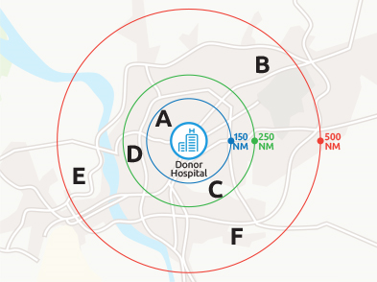

Organ distribution for adult donors age 70 or older and/or DCD donors
For deceased donors older than age 70, and/or who die as a result of cardiorespiratory failure, the distribution sequence will provide earlier access for candidates more local to the donor hospital. Most livers from these donors are accepted for local candidates, since they are most viable when the preservation time between recovery and transplantation is brief.
For livers from these donors, after initial offers to Status 1A and 1B candidates as above, the initial distribution sequence is as follows:
- compatible candidates with a MELD or PELD of 15 or higher, listed at transplant hospitals within a 150 nautical-mile radius of the donor hospital
- compatible candidates with a MELD or PELD of 15 or higher, listed at transplant hospitals within a 250 nautical-mile radius of the donor hospital
- compatible candidates with a MELD or PELD of 15 or higher, listed at transplant hospitals within a 500 nautical-mile radius of the donor hospital
In the example below:
- Offers would go to any compatible candidates with a MELD or PELD of at least 15 listed at Hospital A, which is within 150 nautical miles of the donor hospital.
- Next, offers would go to any compatible candidates with a MELD or PELD of at least 15 listed at Hospitals C or D (within a 250 nautical-mile radius).
- Offers would then go to candidates at Hospitals B, E or F (500 nautical-mile radius).

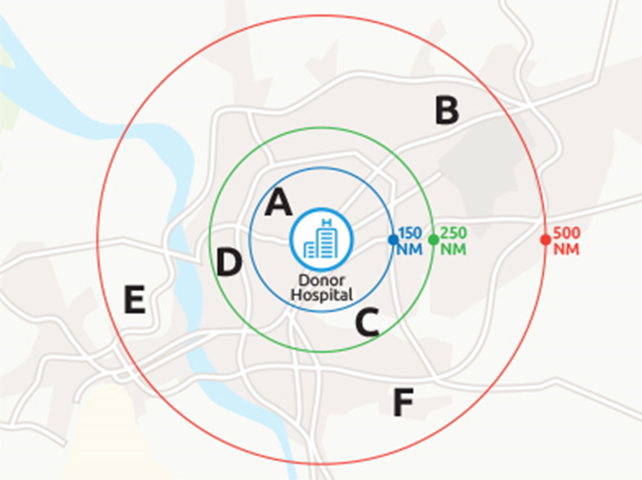

Organ distribution for pediatric (younger than age 18) donors
For pediatric liver donors (younger than age 18), the proposed policy would increase priority for pediatric candidates before any adult candidates at the same level of medical urgency. Livers from pediatric donors would be offered initially to compatible pediatric candidates listed at any transplant hospital within a 500 nautical-mile radius of the donor hospital.
In the example below, pediatric transplant candidates listed at transplant hospitals A, B or C would all be within the initial level of distribution for compatible donor offers.

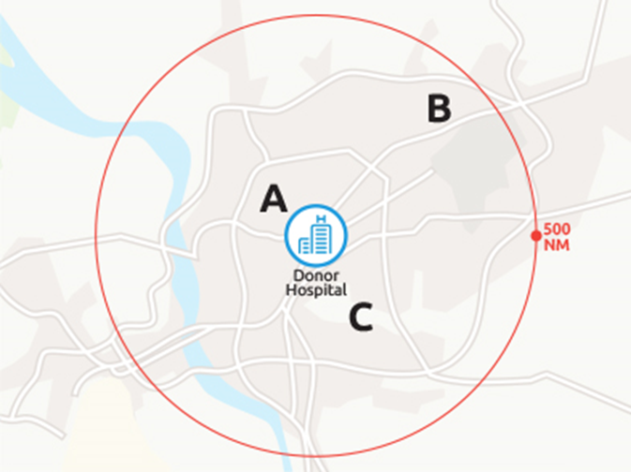

Exceptions for geographically isolated areas
Liver transplant programs located in Hawaii and Puerto Rico are geographically isolated from the continental United States. To address potential challenges to candidate access in those areas, blood type O livers recovered in those two donation service areas will be offered for all local candidates, regardless of blood type, before being offered to any candidates outside those areas.
Also, no transplant program exists in the state of Alaska, and all U.S. transplant programs are beyond a 500 nautical mile distance from donor hospitals in Alaska. For the purposes of this policy, any livers recovered from an Alaskan hospital will be considered as originating from the Seattle Tacoma Airport in Washington State.

For additional information
To learn more about the Liver and Intestinal Organ Transplantation Committee, visit the committee’s page on the OPTN website. If you have additional questions, send an e-mail to liver@unos.org.

